First Nations Fashion and Textiles Plan 2024-2026

This publication may contain images or references to Aboriginal and Torres Strait Islander peoples who are deceased. The Queensland Government does not wish to cause distress to any Aboriginal or Torres Strait Islander community members.

Acknowledgment
The Queensland Government respectfully acknowledges the Traditional Owners and Custodians of this land.
We extend our respect to Elders past and present, and Aboriginal and Torres Strait Islander peoples, as First Peoples of this country.
We acknowledge the continuation of diverse cultural practices and knowledge systems of Aboriginal and Torres Strait Islander peoples.
We acknowledge that Aboriginal and Torres Strait Islander self-determination is a human right as enshrined in the United Nations Declaration on the Rights of Indigenous Peoples.
The Queensland Human Rights Act 2019 also recognises the particular significance of the right to self-determination of Aboriginal and Torres Strait Islander peoples.

Consultation
Arts Queensland would like to thank the many experts who participated in the consultation process to inform the development of the First Nations Fashion and Textiles Plan including: First Nations Arts and Cultures Panel members, representatives from the fashion and textile industry, Indigenous Art Centres, artists and designers, legal firms and agencies, social enterprises, peak bodies, printing and textile manufacturers, education and training providers, commercial retailers and brands and Queensland Government departments.

Introduction
The First Nations Fashion and Textiles Plan 2024-2026 (the Plan) will support First Nations arts and cultural practitioners and communities to realise the ambition for sustainable growth of a First Nations-led fashion and textile industry in Queensland.
Developed through consultation with First Nations creative practitioners, arts workers, Indigenous Art Centre managers, and representatives from the Australian fashion and textile industry, this two-year plan builds on the Queensland Government’s Backing Indigenous Arts initiative, which since 2007 has supported Indigenous Art Centres, First Nations visual arts and craft organisations, and artists working in fashion and textiles.
The Plan is a key deliverable of Creative Together 2020-2030: A 10-Year Roadmap for arts, culture, and creativity in Queensland and its second action plan, Grow 2022-2026. It is centred on a strong and sustainable sector and the key priority of Elevating First Nations arts.
Acknowledging the need to continue to be responsive to the voices of First Nations peoples, Arts Queensland (within the Department of Education) will lead implementation of the Plan in partnership with the First Nations fashion and textile industry in Queensland. An intergovernmental reference group will also be established to support coordinated approaches and enhance national and international opportunities for the industry.

Implementation will be guided by the principles of the Cultural Engagement Framework – Working with Aboriginal and Torres Strait Islander arts and cultures
- Culture and Country: Respect for Culture and Country is fundamental to the identity and wellbeing of individuals and communities. It recognises First Nations peoples’ cultural sovereignty; connectedness to Country and related ancestral lores and customs.
- Leadership: Cultural organisations and institutions must be guided by appropriate representation and leadership by First Nations leaders and employees.
- Authenticity: First Nations peoples have the right to control the content and delivery of First Nations cultural programming, ensuring culturally appropriate development and presentation
- Collaboration: Active and mutually beneficial engagement that is based on free, prior and informed consent is fundamental in the design and delivery of strategies and projects that relate to First Nations cultural materials and communities.
- Accountability: High standards of accountability including truthtelling, representation, fair and open consultation with First Nations peoples will result in stronger relationships and arts and cultural outcomes.
- Self determination: First Nations peoples have pre-existing and continuing rights to maintain, protect and practise culture, and determine who accesses the processes and results of cultural practices, their governance and business.

First Nations fashion and textiles in Queensland
The First Nations fashion and textile industry in Queensland is grounded in more than 65,000 years of cultural and artistic practice and storytelling.
From traditional forms of body adornment to ready-to-wear and high-end couture, artists and designers across the State are creating unique and diverse works that celebrate ancient culture and lineage.

At a glance:
- The diversity of First Nations fashion and textiles in Queensland is a strength, from emerging to established designers and businesses, Indigenous Arts Centres, makers’ markets and small-scale manufacturers.
- Artists and designers work at varying stages of business maturity and scale, operating as social enterprises, sole traders and commercial businesses.
- A growing number of First Nations fashion and textiles practitioners in Queensland have successfully increased their profile and developed First Nations-led fashion brands, commissions and collaborations.
- The creation of end-to-end bespoke collections often occurs within community, with small-scale production sold at art fairs, art markets and retailers.
- There exists a strong commitment to ethical and sustainable production, however this limits the industry’s ability to develop the scale necessary to meet current and future demand.
- Several Queensland-based First Nations fashion and textiles designers, artisans and organisations have expressed interest in building their brands and expanding their capacity to meet growing demand.
- To upscale production, some makers partner with largely non-First Nations led interstate or offshore companies for production and manufacturing.
- While creativity is driving activity in the industry, knowledge of the business of fashion is at an early stage. Access to resources, training and skills development, business support, connection with industry networks and protection of intellectual and cultural property is needed across the industry.
- The industry requires access to equipment and small-scale infrastructure to expand capacity.
- Major fashion brands have embraced First Nations design through significant retail collaborations, with First Nations artists’ work printed on fabric to create capsule collections.
- First Nations designs are also being used on fabric in other clothing ranges such as uniforms and sportswear.

The development of a sustainable and ethical First Nations -led fashion and textile supply
First Nations-led fashion and textiles supply chain The First Nations fashion and textile industry in Queensland is comprised of diverse experience and capacity, with this Plan seeking to support growth across the industry from making to production to enhancing supply chains and connecting artists and designers to markets.
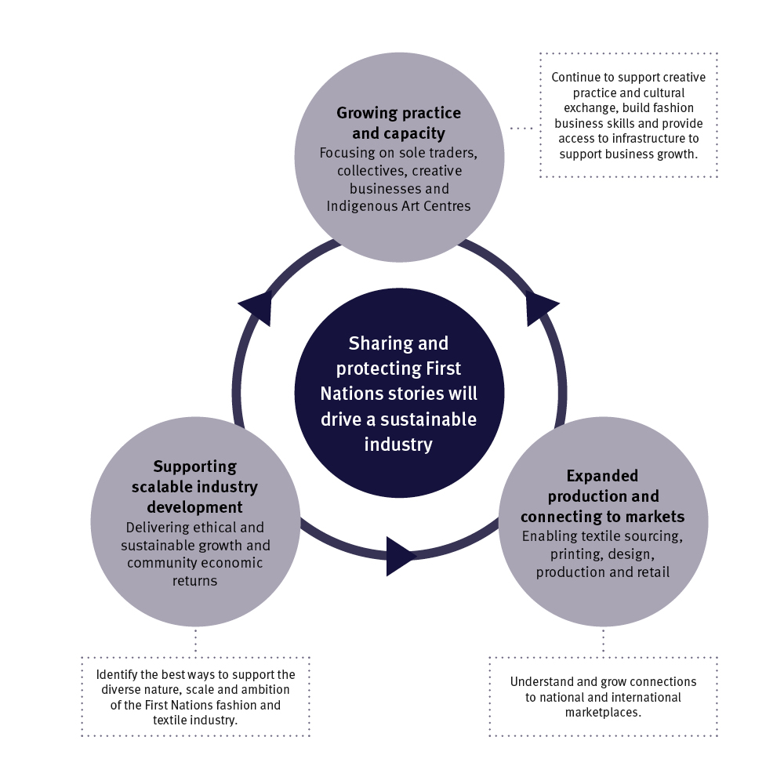

The opportunity
The next two years provide a unique opportunity to drive growth, while working to understand the best approaches to growing the industry.
This Plan seeks to build on the quality and diversity of the First Nations fashion and textile industry in Queensland and leverage the increasing national and international recognition for its unique designs and products.
It works to provide a strong foundation for growth in readiness for bigger markets, including the once-in-a-generation opportunity to showcase and celebrate Aboriginal and Torres Strait Islander arts and cultures on the world stage of the Brisbane 2032 Olympic and Paralympic Games (Brisbane 2032).
This plan also supports delivery of key legacy outcomes of Elevate 2042: The Brisbane 2032 Olympic and Paralympic Games Legacy Strategy working to increase ‘economic, employment and career development opportunities available to First Nations peoples in all aspects of Brisbane 2032 delivery’.
Opportunity exists to support First Nations communities, artists and creatives to share and protect Aboriginal and Torres Strait Islander cultures to build and strengthen fashion and textiles practice, pathways and industry across the State.

Key action areas

Sharing and protecting Aboriginal peoples’ and Torres Strait Islander peoples’ stories.
At the core of the First Nations fashion and textile industry is the sharing of stories and cultures, providing accessible ways for wider audiences and markets to engage with First Nations arts and cultures.
As demand and markets grow for fashion and textiles, the protection of Indigenous Cultural and Intellectual Property (ICIP) is essential to ensuring First Nations arts and cultural practices are protected from appropriation.
The industry has highlighted the need to develop and protect ICIP as central to supporting social, cultural, and economic outcomes for Aboriginal peoples and Torres Strait Islander peoples and communities. They require action to help protect the voice of artists and the broader industry in making, producing and distributing creative and cultural work. This includes navigating complex licensing and royalty payments to ensure First Nations fashion and textiles practitioners can control, own, maintain and develop their ICIP.
Brisbane 2032 has the potential to be a powerful celebration of First Nations arts and cultures, helping to define Queensland’s cultural identity and share our creative talent with the world. To ensure First Nations practitioners and businesses are best supported to embrace this opportunity, ethical approaches that respect and protect artists’ and communities’ cultural and intellectual property will be prioritised and strengthened.

Actions
- Action 1: Work with First Nations experts to develop a First Nations Art and Design Procurement Framework and Guidelines to ensure prioritisation and protection of ICIP
- Action 2: Collaborate with procurement teams across Queensland Government to ensure Queensland artists and creatives are not disadvantaged by procurement policies as a result of their use of interstate or international textile manufacturers.

Growing creative practice and capacity
A thriving First Nations-led fashion and textile industry in Queensland will require a diverse, talented and well-resourced workforce that can grow in scale to meet industry ambition and respond to future demand. Opportunity exists to shape and grow careers, including in design, textile production, print, dye, pattern making, garment construction, retail, product management and more.
Investment in developing and presenting First Nations stories and storytelling through fashion and textiles projects, including creation of new collections, will help cultivate the creative practice of First Nations fashion and textile practitioners.
Several established community-led fashion and textile organisations and social enterprises in Queensland produce works made within community with a focus on traditional and ethical practices.
A range of funding programs exist that support First Nations works that grow creative practice and new collections, while operational funding supports the sustainability of Indigenous Arts Centres and First Nations arts businesses. In addition, First Nations arts business grants support the purchase of services that strengthen business sustainability, skills and capacity.
There remains opportunity to boost the capacity and capability of fashion and textiles practice to grow the sustainability of First Nations fashion and textiles in Queensland. This includes support to access specific infrastructure, equipment, and space upgrades to support small-scale production.

Actions
- Action 3: Launch a First Nations Fashion and Textiles Fund, as a new fund through Grow 2022-2026, to support established First Nations fashion and textiles design businesses, artists and designers to expand production and strengthen business, including through small-scale infrastructure support.
- Action 4: Promote and embed funding to explicitly support First Nations fashion and textiles projects through existing Arts Queensland funding programs.
- Action 5: Partner with training, industry and government to grow and expand career pathways to boost on-the-job and in-community opportunities across the fashion and textiles supply chain.

Connecting to markets
Funding through Grow 2022-2026 and the Backing Indigenous Arts initiative contributes to the operations of Aboriginal and Torres Strait Islander arts and cultural businesses, collectives and organisations, including many working in the fashion and textile industry. Arts Queensland supports the industry by identifying and brokering collaborations and strengthening networks that can support industry opportunities and capacity development.
To build ethical and sustainable fashion and textiles practice, focus is required to connect urban and remote First Nations artists and communities with suitable opportunities and pathways for business development. Access to trusted networks and industry insights that inform makers’ understanding of demand will be foundational for early industry growth and profile raising.
Equally, the brokering of market development opportunities and collaborations and access to market information and data will deliver industry growth. Through the connection of designers with key partners and markets nationally and internationally, larger scale opportunities can be realised.

Actions
- Action 6: Connect market-ready First Nations fashion and textile industry representatives in the state to national and international market development opportunities through industry and government partners.
- Action 7: Partner with industry and government to develop an online portal for First Nations fashion and textiles stakeholders to access information on industry practitioners, market trends and opportunities to showcase Queensland talent.

Enabling scaleable industry development
A strength of the industry is its ability to deliver small-scale collections and garments. However, to achieve wider social and economic outcomes for First Nations businesses and communities in Queensland, the First Nations-led industry will need to upscale and increase output to meet growing demand. This will include creating robust supply chains, increased textile sourcing and distribution to larger markets.
It is necessary to leverage available Queensland Government investment through this Plan to explore partnerships and collaborations that support longer-term industry development and economic outcomes for Aboriginal peoples and Torres Strait Islander peoples.
There is a role for Queensland Government investment to support innovation that will lead to sustainable business models and drive longer-term industry growth to meet large-scale demand. A whole-of-government approach, together with cross-sectoral partnerships is required with a focus on employment and skills development, and production of scale that considers local economies and decision-making.

Actions
- Action 8: A cross-government reference group will be formed to consider options and models to grow scaleable production, including First Nations ownership, community economic return and social enterprises.
- Action 9: Partner with industry bodies to support access to industry data and insights, and new models of industry innovation to support the First Nations fashion and textile industry determine future delivery models.

Measuring progress
The Plan recognises that community-led initiatives and First Nations peoples’ ownership of outcomes will be crucial to the growth and success of a First Nations-led fashion and textile industry in Queensland.
The principles of the Cultural Engagement Framework will guide the nature and pace of the First Nations-led fashion and textile industry’s development, informed by the multiple perspectives of First Nations artists, designers, managers, business owners and communities.
As part of the evaluation of Grow 2022-2026, Arts Queensland will share learnings and outcomes of actions within the Plan over next two years on the Arts Queensland website: arts.qld.gov.au

Case studies

Magpie Goose case study
Magpie Goose operates as a family-run, First Nations-owned social enterprise crafting unique and wearable art pieces that serve as a platform for First Nations storytelling. Magpie Goose generates economic opportunities for First Nations peoples, while promoting cultural expression and reinvesting earnings from commercial trade back into community. In addition to designing and selling clothing, Magpie Goose provides Indigenous employment in its retail store, and engages Aboriginal and Torres Strait Islander communities in modelling the clothes.

Grace Lillian Lee case study
Grace Lillian Lee is a multicultural artist known for drawing inspiration from her First Nations heritage. Grace is a descendant of the Miriam Mer people of the Eastern islands of the Torres Strait, who has been weaving stories through culture and fashion since 2010. Grace has curated fashion performances for the Cairns Indigenous Art Fair and Darwin Aboriginal Art Fair and founded First Nations Fashion and Design (FNFD), a platform for grassroots arts collectives, which runs workshops on country to nurture young First Nations designers.

Yalanji Arts case study
Yalanji Arts, Mossman Gorge operates as an Aboriginal-owned art centre, providing support and advocacy for Kuku Yalanji artists from Mossman Gorge and the surrounding area. The centre specialises in handcrafted ceramics, screen printed textiles and prints on paper that express connection to the Kuku Yalanji Country. Yalanji Arts has strong potential for significant growth in fashion and textile spaces.

CIAF case study
Cairns Indigenous Art Fair (CIAF) provides an ethical marketplace and platform for First Nations artists and designers to exhibit work, and facilitates the sale and acquisition of First Nations art. The CIAF Fashion Performance, established by Grace Lillian Lee in 2013, is recognised as a unique showcase for contemporary First Nations fashion, installation and performance. With an annual attendance of approximately 50,000 visitors, CIAF is a significant event for domestic and international art curators and collectors generating more than $7 million to the Queensland economy.

Delvene Cockatoo-Collins case study
Delvene Cockatoo-Collins is a First Nations artist and designer living and working on Quandamooka Country. Delvene’s portfolio includes ceramics, sculptures, homewares, women’s wear and jewellery, all of which reflect her deep cultural roots passed down through generations. She oversees every aspect of the textile supply chain from designing, fabric dyeing and screen printing on her 10-metre table to sewing the garments. Delvene has gained international exposure and in 2023 was hosted by the Australian Consulate in New York, where she facilitated twine making workshops, further showcasing her artistry to global markets.


The Queensland Government is committed to providing accessible services to Queenslanders for all cultural and linguistic backgrounds.
If you have difficulty understanding this publication and need an interpreter, please call the Translating and Interpreting Services (TIS National) on telephone 131 450 and ask them to contact the department on 13 QGOV (13 74 68).
State of Queensland (Department of Education, 2024). Licensed under CC BY 4.0, with exception of the government coat of arms, logos and images.

